**SET A**

**SRM Institute of Science and Technology**

**College of Engineering and Technology**

**School of Computing**

**Department of Networking and Communications**

SRM Nagar, Kattankulathur – 603203, Chengalpattu District, Tamilnadu

**Academic Year: 2022-23 (Even)**

**Test: CLA-T2** **Date: 03-05-2023**

**Course Code & Title:** 18CSE382T Forensics and Incident Response **Duration:** 60 minutes

**Year & Sem: III Year / V Sem** **Max. Marks:** 30

**Course Articulation Matrix:**

***CO 5; Understand the windows and linux investigation procedures.***

***CO 6: Introduce the report writing guidelines and principles***

| **S.No.** | **Course Outcome** | **PO1** | **PO2** | **PO3** | **PO4** | **PO5** | **PO6** | **PO7** | **PO8** | **PO9** | **PO10** | **PO11** | **PO12** |
| --- | --- | --- | --- | --- | --- | --- | --- | --- | --- | --- | --- | --- | --- |
| 1 | **CO5** | H |  |  | H |  |  |  |  |  |  |  |  |
| 2 | **CO6** | H |  |  |  |  | H |  |  |  |  |  |  |

|  | **Part C (3*10=30**) | **Marks** | **BL** | **CO** | **PO** | **PI Code** |
| --- | --- | --- | --- | --- | --- | --- |

| **1** | Corporate the following procedures for corporate high-tech investigation   1. E-Mail abuse investigation 2. Media leak investigation   (OR) | **10** | **4** | **5** | **4** | **1.3.1** |
| --- | --- | --- | --- | --- | --- | --- |
| **2** | Evaluate the problems and challenges forensic examiners face when preparing and processing investigations, including the ideas and questions they must consider. | **10** | **5** | **5** | **4** | **1.2.1** |
| **3** | Analyze and explain the following.   1. Computer forensic Software tools 2. Computer Forensic hardware tools   (OR) | **10** | **4** | **6** | **6** | **1.6.1** |
| **4** | Elaborate in detail on forensic report writing with an example. | **10** | **4** | **6** | **6** | **2.6.3** |
| **5** |  | **10** | **6** | **5,6** | **4,6** | **5.5.1** |

**\*Program Indicators are available separately for Computer Science and Engineering in AICTE examination reforms policy.**

**Course Outcome (CO) and Bloom’s level (BL) Coverage in Questions**

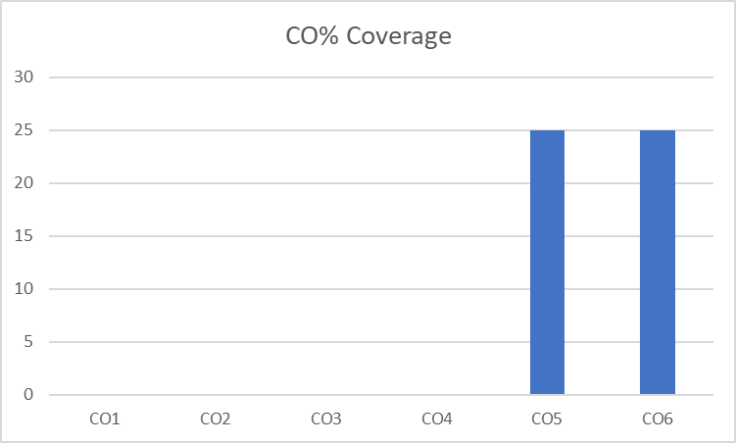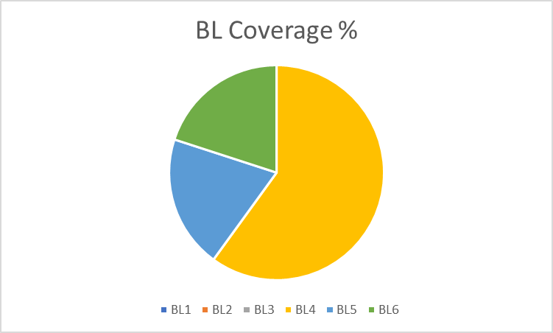

**Approved by the Scrutiny**